Salvador Dali
Salvador Dali was part of the surrealist movement in art which was primarily through visual art works and writing, and lasted from the late 1920s and peaked around the 1930s, but is still active even today. The art is showcased strange creatures created from everyday objects in scenes with photographic styles, making the unsettling scenes paradoxically realistically and unrealistically looking. Surrealism is an expression of dreams into reality creating what surrealist call a “Super Reality”, they used techniques to let the unconscious express itself. Surrealist first and foremost considered the movement a philosophy and above all a revolutionary movement, and that the pieces of art created were only an artifact of the movement. The movement branched out into many areas including Film, music, art, and writing while it gained traction as more than just a form of expression it evolved into a method to expose physiological truths seen through objects being turned into something more in order to invoke empathy in viewer. Salvador Dali was born May 11 1904 in Figueres Span and died there on January 23 1989. In the early 1920s studied at the Real Academia de Bellas Artes de San Fernando, and in his later studying years meet Pablo Picasso and other influential artist who came from the surrealist movement. Salvador Dali was most famous for his brightly sunlight landscapes that featured normally a more disturbing image in it that held symbolism. An example of this is the piece “The Great Masturbator” The piece contains bright sunlight colors with a distorted naked women, near the legs of a man with no pants on, and also a locust at the bottom of the painting to represent Dali’s fear of Sexually transmitted diseases. The purpose of his works like these is to show an almost shocking image that is done with the precision of a realism artist to invoke thoughts on things like the passage of time. He used many odd techniques to find inspiration and to create art, it is said that he would go into a dream like trance and paint using his subconscious. Other more realistic techniques included blowing up a paint cartridge onto his canvas and throwing ink onto canvases. He worked with many mediums such as oil and combined tempera with pointillism.
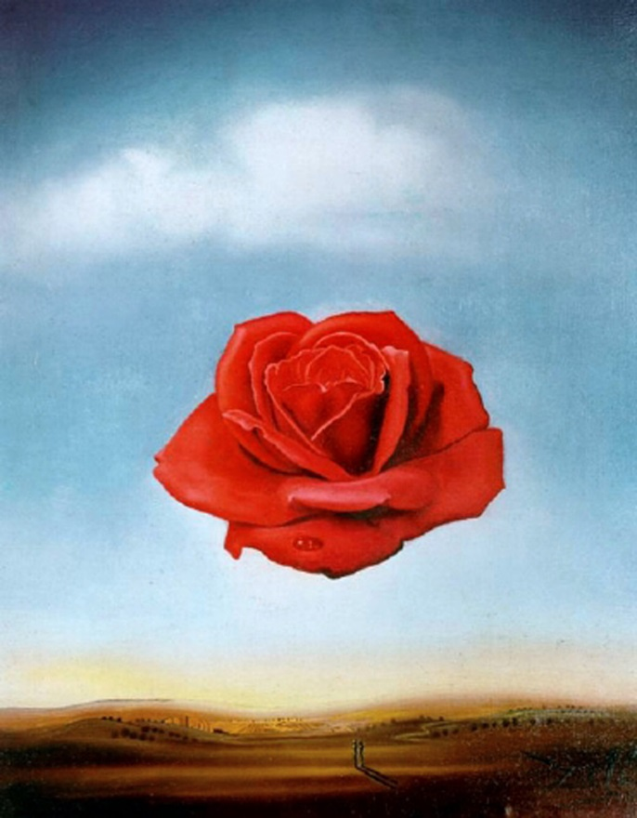
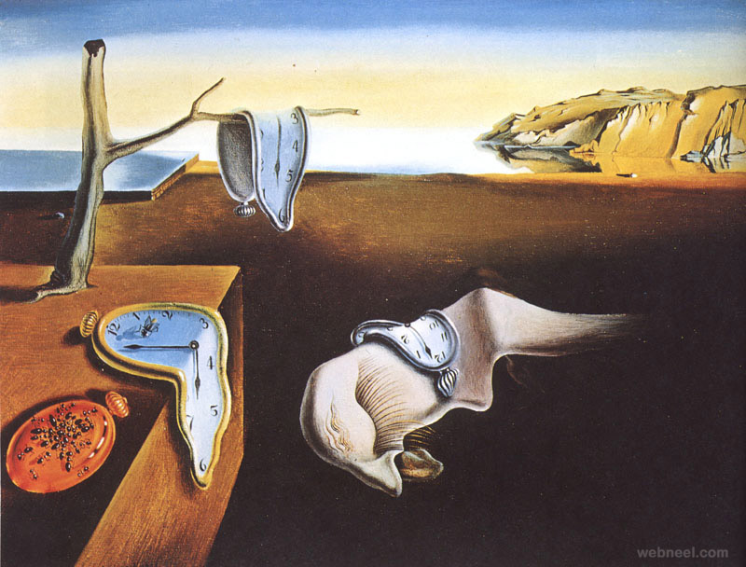
One of Dali’s most famous paintings is the Persistence of Memory which was done with oil on canvas. It show showcases a dimly lit flat earthen plain which had a sunlight ocean and cliff in the background. There is a single tree branch, block of wood, and something that looks like a blanket. On these objects are clocks that appear to be melting and are semi liquid in form. Another one of Dali’s artworks is the Meditative Rose which was done in 1958 with oil on canvas. It is primarily a painting of a rose which is extremely detailed and is floating the middle of the painting in front of a blue sky with a single fuzzy cloud above it. The bottom of the painting is a desert like landscape that has rolling hills with a few dark shrubs dotting the hills. A part that really stands out is two tiny dark figures that are standing in the bottom middle of the painting

The Persistence of Memory

The Meditative Rose
Sources: http://www.ehow.com/way_5406102_dali_s-techniques.html
http://www.theartstory.org/artist-dali-salvador.htm
http://www.biography.com/people/salvador-dal-40389

